

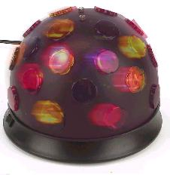 | - Good for any occasion!  - Music variety from 50’s - Today.  - Price depends on event - Starts at $250.  - See website for more details.

 | 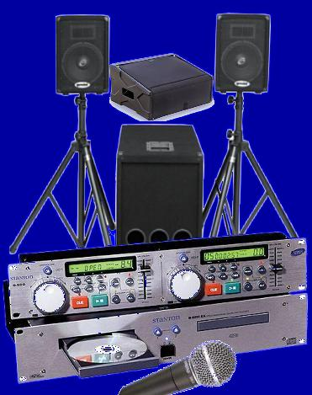
  Contact DJ Mike B:
  
  See my webpage for
  Song list &
  Personal info.
  

